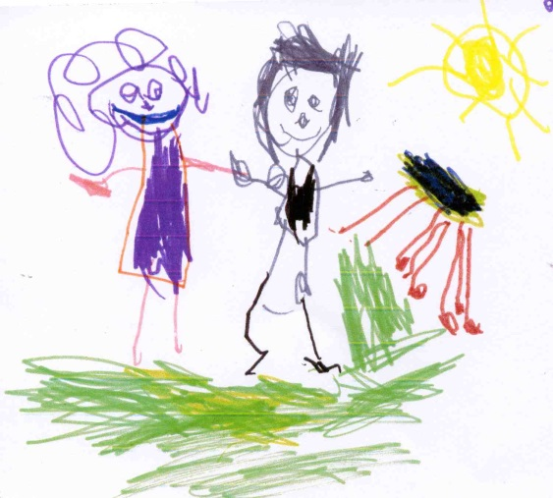

Rainhill Community Nursery School

Supporting Learning
at Home

Pack 3

At Rainhill Community Nursery School, we support the children to develop their independence. The routine of the session provides them with the confidence to carry out daily tasks e.g. hanging up their coat. These opportunities encourage the children to develop patience, resilience and concentration. To continue this learning at home, we have put together a selection of activities that you could complete alongside your child.
Make My Bed | Set The Dinner Table | Clean The Dishes | Fasten Buttons on My Clothes
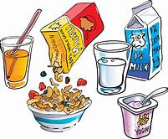  Make Myself Breakfast | Use a Knife and Fork | Water and Care For Plants | Sort Out My Recycling
Fasten My Coat Zip  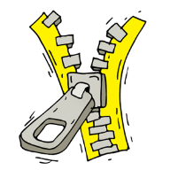 | Dress Myself | Clean My Bedroom | 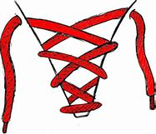  Tie My Shoelaces

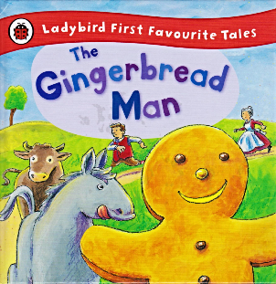
The Gingerbread Man
Share the story of ‘The Gingerbread Man’. If you do not have a copy of book at home, you can access an audio version online.

Try to ensure there are minimal distractions. This will support your child to focus on what you are reading. Talk about the illustrations, prompting them to vocalise what they can see. Encourage discussion about the setting, events and characters or begin to predict what might happen next. Allow your child to join in with the repetitive refrains in the story e.g. “Run, run, as fast as you can, you can’t catch me, I’m the gingerbread man”. These techniques will support your child to become an independent reader.
When confident you could record your child retelling the story. It would be wonderful to send this to friends and family, who you are unable to see at the moment. It would be a joy for them to listen to!
Linked Activities
If you have the ingredients available, you could make your own gingerbread people and decorate them.
Ingredients
350g Plain Flour
1tsp Bicarbonate of Soda
2tsp Ground Ginger
1tsp Ground Cinnamon
125g Butter
175g Light Soft Brown Sugar
1 Egg
4tbsp Golden Syrup
- Sift together the flour, bicarbonate of soda, ginger and cinnamon in to a bowl.
- Add the butter and blend, until the mixture looks like breadcrumbs.
- Stir in the sugar.
- Lightly beat the egg and golden syrup together.
- Add to the mixture, until it clumps together.
- Tip the dough out and knead briefly until smooth.
- Preheat the oven to 180C and line two baking trays with greaseproof paper.
- Roll the dough out on a lightly floured surface. Using cutters, cut out the gingerbread people and place on the baking tray, leaving a gap in between them.
- Bake for 12-15 minutes or until lightly golden brown.
Gingerbread Man Dice Game

Roll the dice and recognise the number it landed on. At the end of the game you should have completed your gingerbread man!
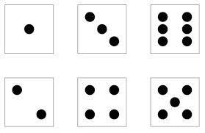
1 - Draw the Eyes
2 - Draw the Clothes
3 - Draw the Smile
4 - Draw the Buttons
5 - Draw the Bow
6 - Draw the Hair
Nursery Rhymes
We use Nursery Rhymes to enhance children’s learning and development. It encourages them to expand their vocabulary and encounter new words, improve their understanding of rhythm and pattern, extend their concentration, memory and thinking and develop their understanding of rhyme. All of the above are essential to their development in Literacy and Phonics. It would be wonderful if you could share these together:

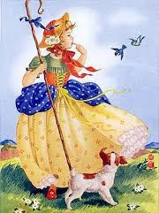
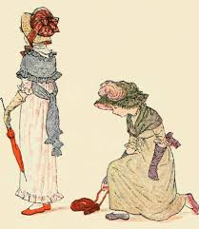
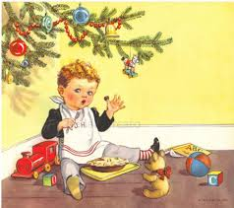
Little Bo Peep Little Jack Horner Lucy Locket

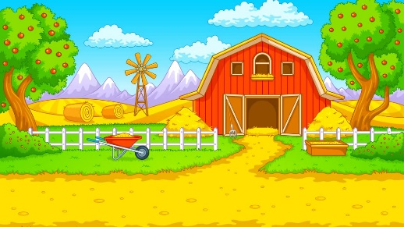
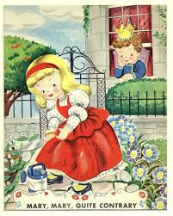
Mary, Mary, Quite Old Macdonald Had a Farm 5 Little Monkeys
Contrary

Phonics Activities
These learning opportunities concentrate on developing children’s speaking and listening skills, phonological awareness and oral blending and segmenting. It will enhance their understanding of linking sounds and letters in words and naming and sounding the letters of the alphabet. This will support them in their reading and writing.
Noisy Neighbour
Tell a simple story about a noisy neighbour and invite your child to join in.
“Early one morning, the children were all fast asleep”. Encourage your child to close their eyes. “When all of a sudden they heard a sound from the house next door”. Adult will then make a sound. “Wake up children. What’s that noise?”. Allow them time to identify the sound. Then together, join in with “Noisy neighbour, please be quiet. We are trying to sleep”. Repeat the simple storyline with another sound e.g. snoring, brushing teeth, munching cornflakes, yawning, stamping feet, washing.

Encourage your child to add their own ideas…

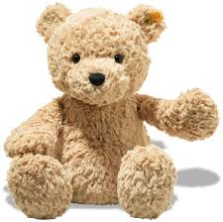
Toy Talk
Introduce a soft toy to your child, that can only speak in sound talk. Ask the toy a question e.g. “What would you like for dinner today?” The toy speaks silently in your ear. Repeat the sounds ‘ch-ee-se’. Look puzzled and then say with relief ‘cheese’. Say ‘ch-ee-se’ and encourage your child to repeat it. Ask the toy again. What else would like? Ensure you think of items containing only one syllable e.g. fish, cake, pie, soup. You can add different scenarios e.g. What does the toy like to do in the garden? Hop, skips, jump, run.

Number Poems
We use number poems to reinforce the children’s number skills. We regularly use the poems when identifying numbers and encourage the children to recognise each numerals features. The poems also support the children’s efforts when they begin writing numbers.

0 Make an oval like an O, then you have a zero!
1 Number one is like a stick, a straight line down that’s very quick!
2 Half a heart will never do. Slide to the right to make a two.
3 Around and around, just like a bee, that’s the way to make a three!
4 Make an L, but wait there’s more, add a stickman to make a four.
5 Make the top, make the side, make the front of the hive. Then you have a
number five!
6 Start at the top, slide down so quick, loop back around to make a six!
7 Across the sky, straight down from heaven, that’s the way to make a seven.
8 Make an S, like a snake. Loop back up to make an eight.
9 Make a balloon that’s just fine, add a stickman to make a nine.
10 Stickman, Stickman, you’re my friend, add a zero to make a ten.
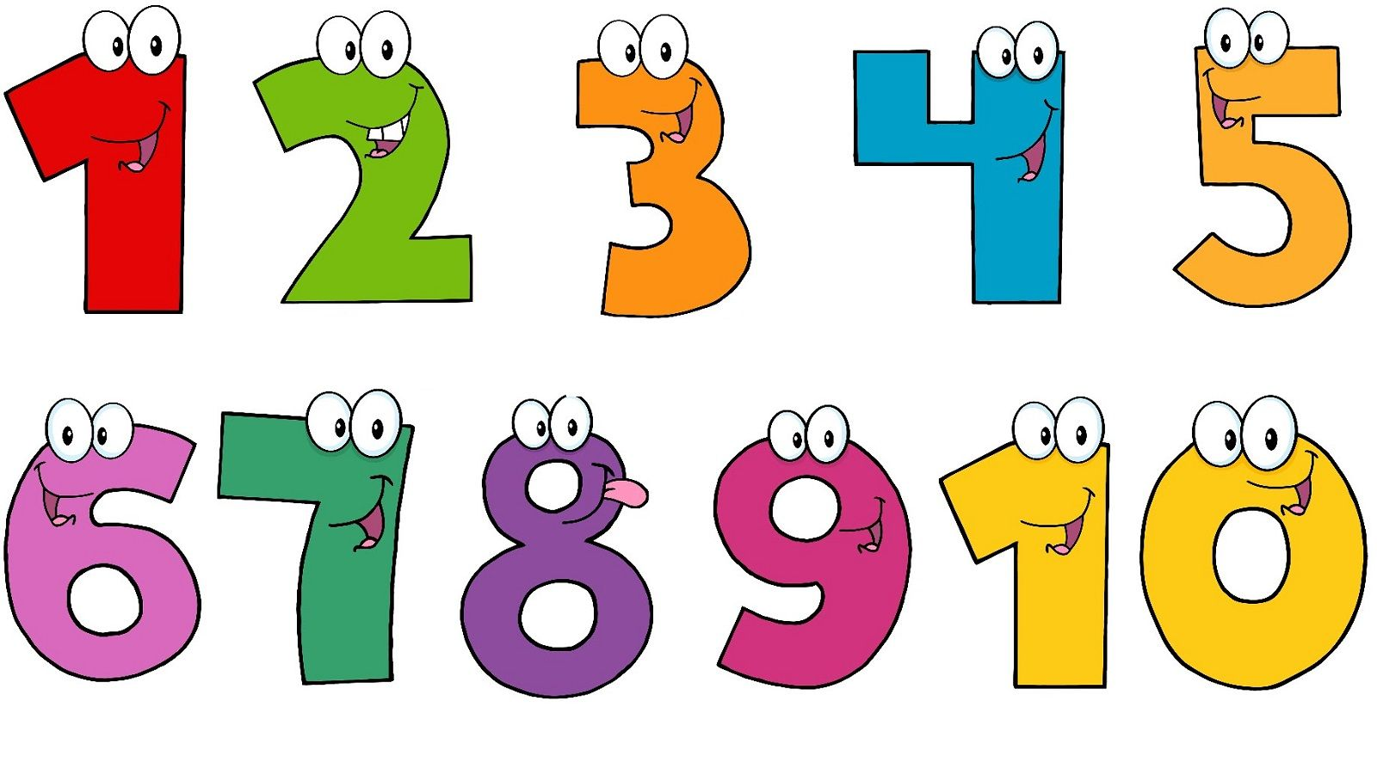
Counting Objects to 10

When playing with building bricks or small toys, encourage your child to count how many of each colour or size.

Support your child to help make simple recipes by counting amounts, e.g. ‘Can you put 2 spoons of cocoa into the bowl?’

Play simple board games and encourage your child to count the spots shown on the dice and the number of spaces to move.

Sing number-themed counting rhymes and use your fingers or small props to help count the items, e.g. 10 Green Bottles.

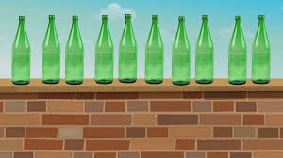

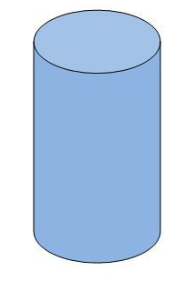
3D Shapes

Look at some empty packages and boxes. What shape are they? Can you find a cube, cylinder or cuboid?

Use some play dough to make 3D Shapes. Can you make a pyramid, cylinder, cube?

Go on a 3D Shape hunt around your house or garden. What 3D Shapes can you find?

Use some empty cardboard boxes and packaging to make a model e.g. a house, car, castle or robot. Talk about the shapes you use.

Fine Motor Activities
Fine motor skills involve the use of the small muscles that control the hand, fingers and thumb. They help children to complete important tasks such as; dressing, feeding, drawing and writing. The ability to complete these independently will increase confidence and self-esteem.
Activity 1

The sun should be beginning to appear through the clouds. You could encourage your child to use the pegs to hang out washing on a washing line.
How many pieces can you hang out using two pegs?
Activity 2

If you have a hole punch available at home. Use this to make holes in tissue paper, card or leaves you have collected from the garden.
Can you count the holes as you make them?

Exploring The Weather
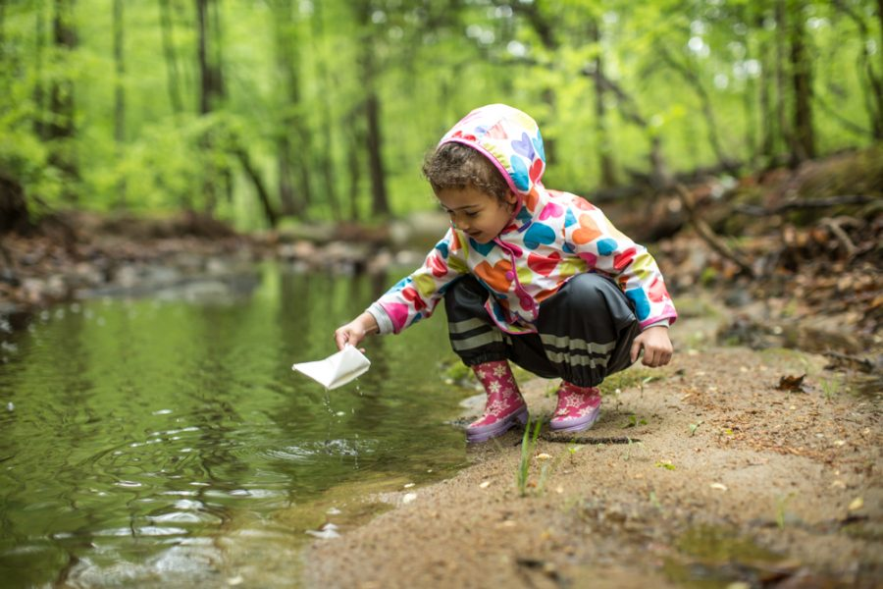

Make a Storm
Rub your hands together. Snap your fingers and clap your hands. Tap your legs and stamp your feet, to create the sound of a storm. Then reverse all the movements as the storm begins to fade. You could even turn a light off and on to make the lightening.
Rain Catcher
Explore the weather when it is raining. Take your child outside to jump and splash in the puddles. You could even make a rain collector. Place a container in your garden and observe how much rain it collects each day. If you want to make a weather man, use a wooden spoon. Add a face and make a mark for each centimetre. This will encourage you to measure how much has fallen.
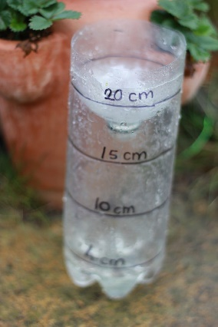
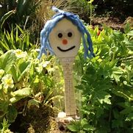

It would be wonderful to see you completing some of these activities at home. Photographs can be emailed to rainhillnursery@sthelens.org.uk. Stay Safe

