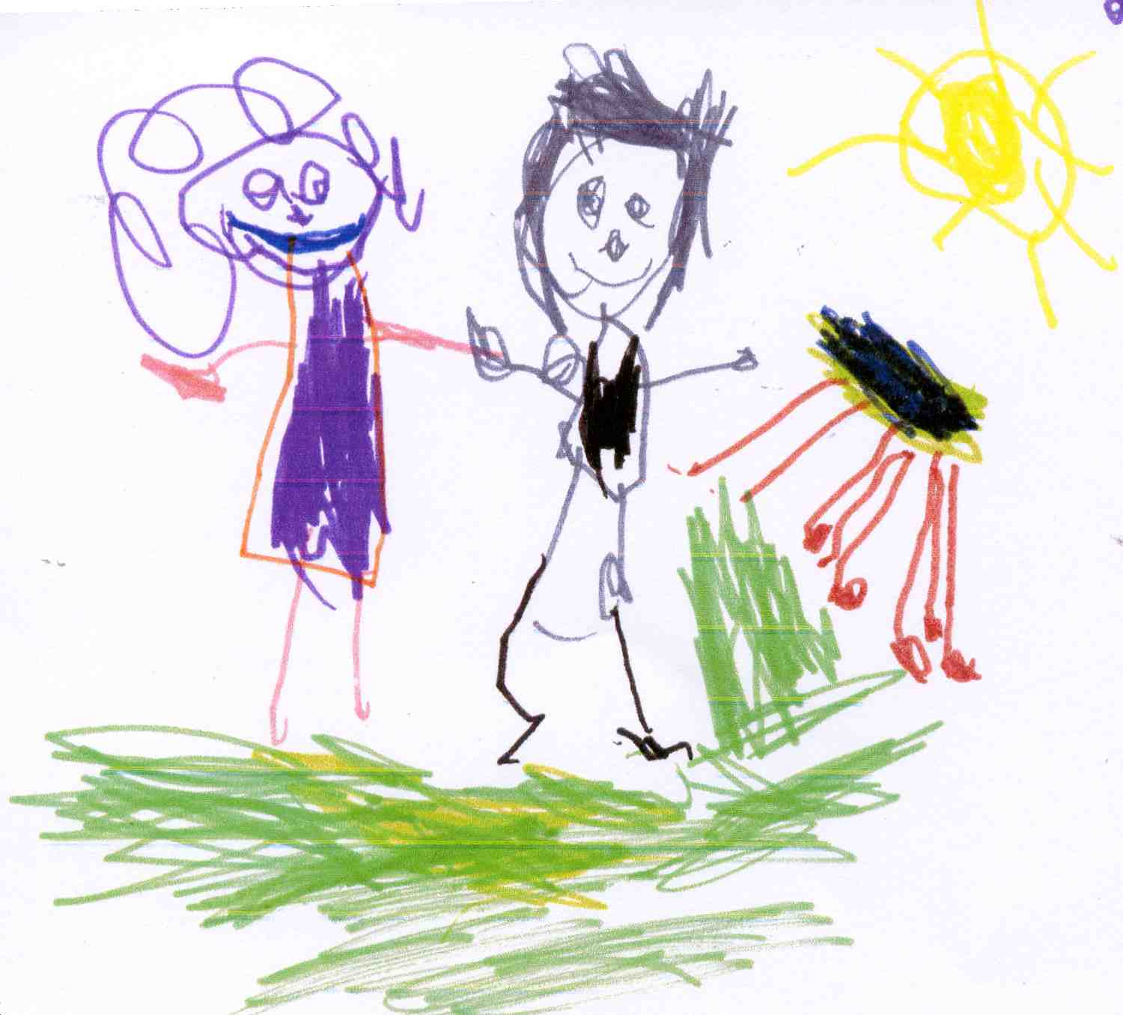Early Years Pupil Premium Strategy Statement: Rainhill Community Nursery School 2020-21
- Summary information
School | Rainhill Community Nursery School
Academic Year | 2020/21 | Total EYPP budget | £1,208 | Date of most recent EYPP Review | Sept 2020
Total number of children | 62 | Number of children eligible for EYPP | 04 | Date for next internal review of this strategy | Jan 2021

- Current attainment (Exit Data is taken from March 2020 due to COVID 19)
 | Children eligible for EYPP | Children not eligible for EYPP
% achieving the level expected/above the level expected for their age in Prime Areas | 60 | 89
% achieving the level expected/above the level expected for their age in literacy | 60 | 75
% achieving the level expected/above the level expected for their age in mathematics | 60 | 76
% making at least good progress from starting point in Prime Areas | 80 | 90
% making at least good progress from starting point in literacy | 60 | 81
% making at least good progress in mathematics | 60 | 84

- Barriers to future attainment
In-school barriers
A | Individual barriers to learning identified on entry and interventions and support are put into place to enable children to access learning
External barriers
A | A small number of children eligible for EYPP have identified additional needs and are being monitored through SEND Plans
B | The majority are children who will only access 3 terms Nursery Education
- Desired outcomes
A | Improve literacy skills for children eligible for EYPP on transition to Reception class
B | Improve mathematical skills for children eligible for EYPP on transition to Reception class
C | Develop children’s characteristics of effective learning (COEL)

- Planned expenditure
Academic year | 2020-21
- Quality of teaching for all
Desired outcome | Action / approach |  | What is the evidence and rationale for this choice? | How will you ensure it is implemented well? | Staff lead | When will you review implementation?
Deliver quality first teaching to all EYPP children, matched to the children’s level of development providing sufficient challenge to accelerate learning across the identified areas of learning. | Small group sessions are differentiated according to children’s level of development. |  | Invest EYPP to create longer term change which will help all pupils.  Small group interventions with highly qualified staff have been shown to be effective, as discussed in reliable evidence sources such as Visible Learning by John Hattie and the EEF Toolkit. | Identified staff deliver interventions.  Children’s progress monitored regularly through progress meetings.  Use staff meeting and INSET to embed a consistent approach | Class Teachers | Jan 2021
Improve outcomes Characteristics of Effective Learning (COEL) | Tracking of progress in COEL in order to accelerate progress. |  | Research undertaken by the Sutton Trust identifies two intervention strategies, which evidence shows make the greatest impact on Pupil Premium investment. There are: feedback and meta-cognition/self-regulation (or learning-to-learn strategies), both of which the research shows add an additional eight months of progress over a year. This approach is integral to our provision for all children. We want to further develop the skills of staff in promoting COEL in all children who attend Rainhill Community Nursery School.  Ferre Leavers identifies that high levels of well-being and involvement lead to deep level learning. | Outcomes reviewed alongside termly tracking of the 7 areas of learning.  SSTEWS evaluations and scrutiny of practice focused on the role of the educator in supporting, scaffolding and articulating learning. | Class Teachers | Jan 2021
Total budgeted cost |  |  |  |  |  | £906
- Targeted support
Desired outcome | Action/approach |  | What is the evidence and rationale for this choice? | How will you ensure it is implemented well? | Staff lead | When will you review implementation?
Improved outcomes in Communication & Language and in Literacy | Small group sessions to support children’s communication and language skills to build a firm foundation for future Literacy skills. |  | Research undertaken by the Sutton Trust identified that Phonics and Small Group Tuition adds an additional four months development to children’s progress.  The research that underpins both the ECAT and ELKLAN Strategies shows that children’s language skills benefit most from having conversations with responsive adults. Our curriculum aims to create a language rich environment underpinned by a strong focus on Literacy which supports children’s listening, attention and vocabulary though retelling narratives and singing songs and rhymes which supports early Literacy. | Organise sessions to ensure staff deliver frequent interventions for identified children.  Frequent monitoring and scrutiny of practice is planned and effectiveness and impact will be measured through data analysis. | Class Teachers | Jan 2021
Total budgeted cost |  |  |  |  |  | Nil additional
- Other approaches
Desired outcome | Action/approach |  | What is the evidence and rationale for this choice? | How will you ensure it is implemented well? | Staff lead | When will you review implementation?
Children have access to Extended Nursery provision (Additional session, Breakfast, Lunch or After-School Club) and curriculum enhancements | Invite parents of EYPP Pupils to take up extended service sessions. Parents of EYPP Pupils will not be asked to make a donation to support the cost of school outings and experiences |  | Research undertaken by the Sutton Trust identified that participation in enhancement activities such as arts, sports and extended schools accelerated progress by an additional two months | EYPP parents will be targeted and notified of the offer of taking up an extended service. | Office staff | Jan 2021
Total budgeted cost |  |  |  |  |  | £302
- Review of expenditure
Previous Academic Year |  | 2019-20 (Exit Data is taken from March 2020 due to COVID 19)
- Quality of teaching for all
Actions | Intended Impact | Monitoring Activity |  | Resource Implications |  |  | Evaluation / Impact on Learning and Development
Deliver quality first teaching to all EYPP children, matched to the children’s level of development providing sufficient challenge to accelerate learning across the identified areas of learning. | Children make expected or better progress. Areas for development are swiftly identified and progress is accelerated where necessary. An appropriate level of challenge is provided for more able pupils. | Termly progress checks. |  | Contribution to cost of employing an additional member of staff to reduce ratios |  |  | The large majority of children eligible for EYPP make typical or better progress in the Prime Areas (80%), Literacy (60%), Maths (60%).
- Targeted support
Actions | Intended Impact | Monitoring Activity |  | Resource Implications |  |  | Evaluation / Impact on Learning and Development
Improved outcomes in Communication and Language and in Literacy | Children, identified as being at risk of delay, or with barriers to learning in this area are supported to make accelerated progress. | Baseline / Progress Meetings  Monitoring cycle- targeting EYPP pupils through Learning Walks / Child Tracking / Learning Journal Scrutiny  Termly report to Governors on impact of EYPP work |  | Maintenance of lower than required ratios in order to facilitate intervention, acceleration and achievement of targets |  |  | 60% of EYPP pupils attained the age related expectation on exit and made typical or better progress in this area.
- Other approaches
Desired outcome | Action/approach | Estimated impact: |  | Lessons learned |  |  | Cost £906
Children have access to Extended Nursery provision (Additional Session, Breakfast, Lunch or After-School Club). | Children are supported to access more than the universal 15 hour entitlement | Review of take up of extended services offer. |  | Cost of additional sessions |  |  | 3 of the 5 eligible pupils took up the offer of an additional extended service session.

